1. 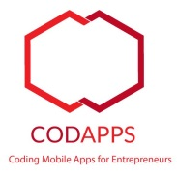You need first to create a free account with Codename One (the tool we use to create apps).

Level of difficulty:   
Estimated time: 15 mn

[**www.codapps.io**](http://www.codapps.io)by Clement Levallois **@codapps_io** [**www.coursera.org/learn/codapps**](http://www.coursera.org/learn/codapps)



**Module 4: Testing your app on a phone and distributing it**

*How to test your app on an Android phone*

To do so, visit their website at [www.codenameone.com](http://www.codenameone.com) and select “Sign up”.

Choose the free version. You are not obliged to choose to receive the newsletter.

Please open the confirmation email you will receive and click on the link in it to confirm the creation of your account.

1. In NetBeans, right click on the title of your project and select “Send Android Build”

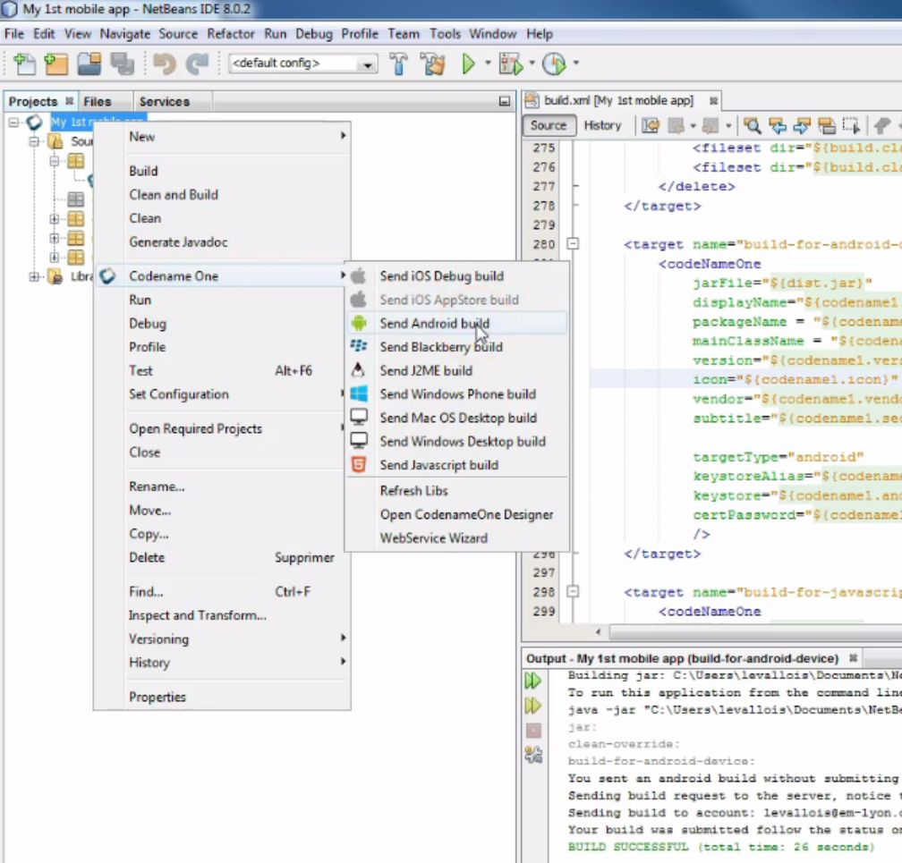

1. This starts the creation of package ready to be sent to Codename One. Two alert windows will open:

* One asking for the login and password of your Codename One account (that you just created)
* One telling you that your app has a provisional certificate. This is ok.

1. You know the process finished successfully when you see this in the bottom panel of NetBeans:

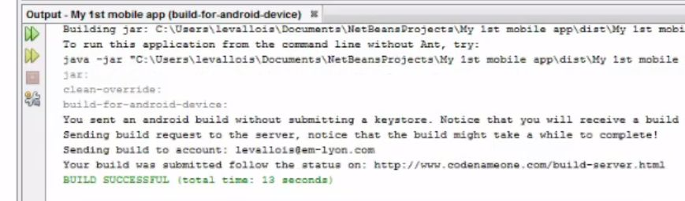

Level of difficulty:   
Estimated time: 15 mn

[**www.codapps.io**](http://www.codapps.io)by Clement Levallois **@codapps_io** [**www.coursera.org/learn/codapps**](http://www.coursera.org/learn/codapps)



**Module 4: Testing your app on a phone and distributing it**

*How to test your app on an Android phone*

**Note**: you don’t see this output window at the bottom of NetBeans? In this case, in the menu of NetBeans, select “Windows” then “Output”, it should make it appear:

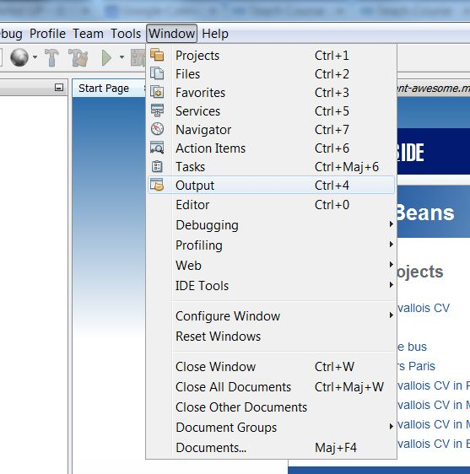

1. Now, you must enable your phone: Indeed, you will probably not be authorized to install the app on your phone, because of the security settings of your phone which says it is of “unknown source”. You will also be warned that it is unsafe to download or install an app which is not coming from an official source. Of course, this is your own app, so it is actually safe.

Level of difficulty:   
Estimated time: 15 mn

To unblock your phone and be able to install apps from “unknown sources”:

Go to the Parameters of your Phone

Go to “Security” settings

Enable “Unknown sources”

Don’t worry, of course the users will not need to do this step when they use your app, since your app will be distributed in an official way through the Android Play Store!

1. You can now go to the website of Codename One, where your app has been sent to create the Android version of it. Login, then go the the Dashboard (in the menu on top of the page).

[**www.codapps.io**](http://www.codapps.io)by Clement Levallois **@codapps_io** [**www.coursera.org/learn/codapps**](http://www.coursera.org/learn/codapps)



**Module 4: Testing your app on a phone and distributing it**

*How to test your app on an Android phone*

1. You will see the status of your app:

* blue -> in progress
* green -> finished, ready to be used
* red: something went wrong, your Android app could not be created.

1. When the status turns green, you are ready to install the app on your phone!

**click on the green status.** A series of option appears to install your app on your Android phone:

* Easiest.option: Flash the QR code from your Android phone, this will download the app on your phone and you’ll be able to install it.
* An email link: click on the link, and an email will be sent to the email address of your Codename One account. Open this email from your phone, click the link in it and this will start the download + installation process. You will get warnings, just click on OK. Your app should install correctly, since you unblocked your phone on step 5.